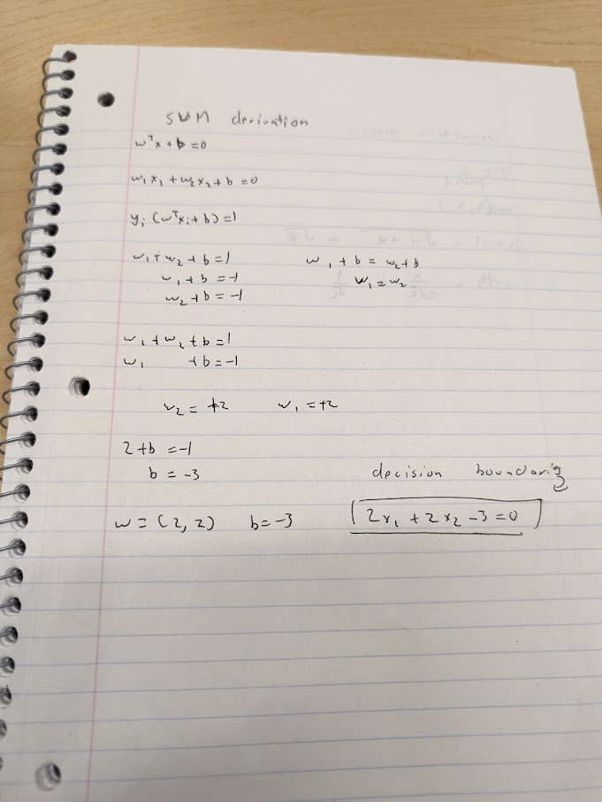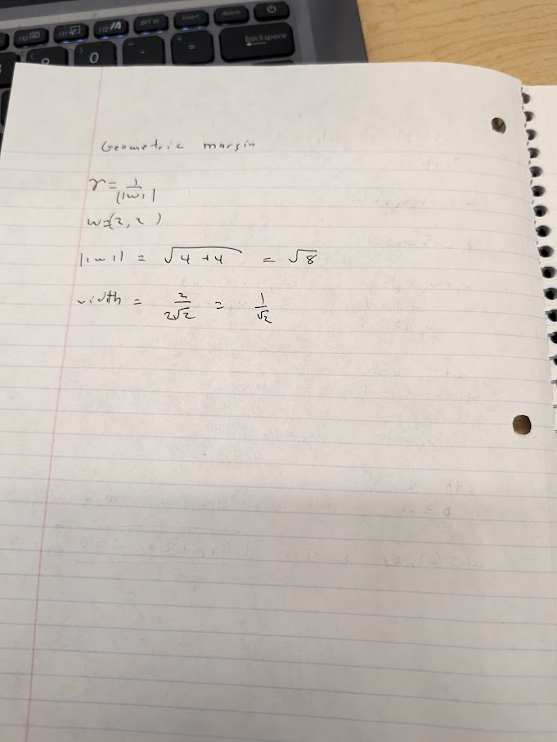
https://chatgpt.com/share/6aee6e83-99b0-83e8-838f-5b769da7ad4d

